
Energy and electricity |  | Year 6 |  |  | Unit 2
Assessment task — Exploring energy and electricity
Name |  |  | Class
Teacher |  |  | Date

Task
You will analyse requirements for the transfer of electricity in a circuit and describe how energy can be transformed from one form to another to generate electricity. You will also use scientific knowledge to assess energy sources selected for a specific purpose.
Instructions

This task is made up of two parts as detailed below.

Part A: Circuits

Design, construct and conduct a way to test the components of a circuit to identify a fault.

Part B: Energy sources

Identify energy sources that can be used to generate electricity and assess each source.

Note: Your teacher will provide you with the materials required to conduct your testing in Part A.

Part A: Circuits

You have been studying electricity and circuits in class this term. While you are at the local show you notice that the Steady Hand Game has been allowing everyone to win.
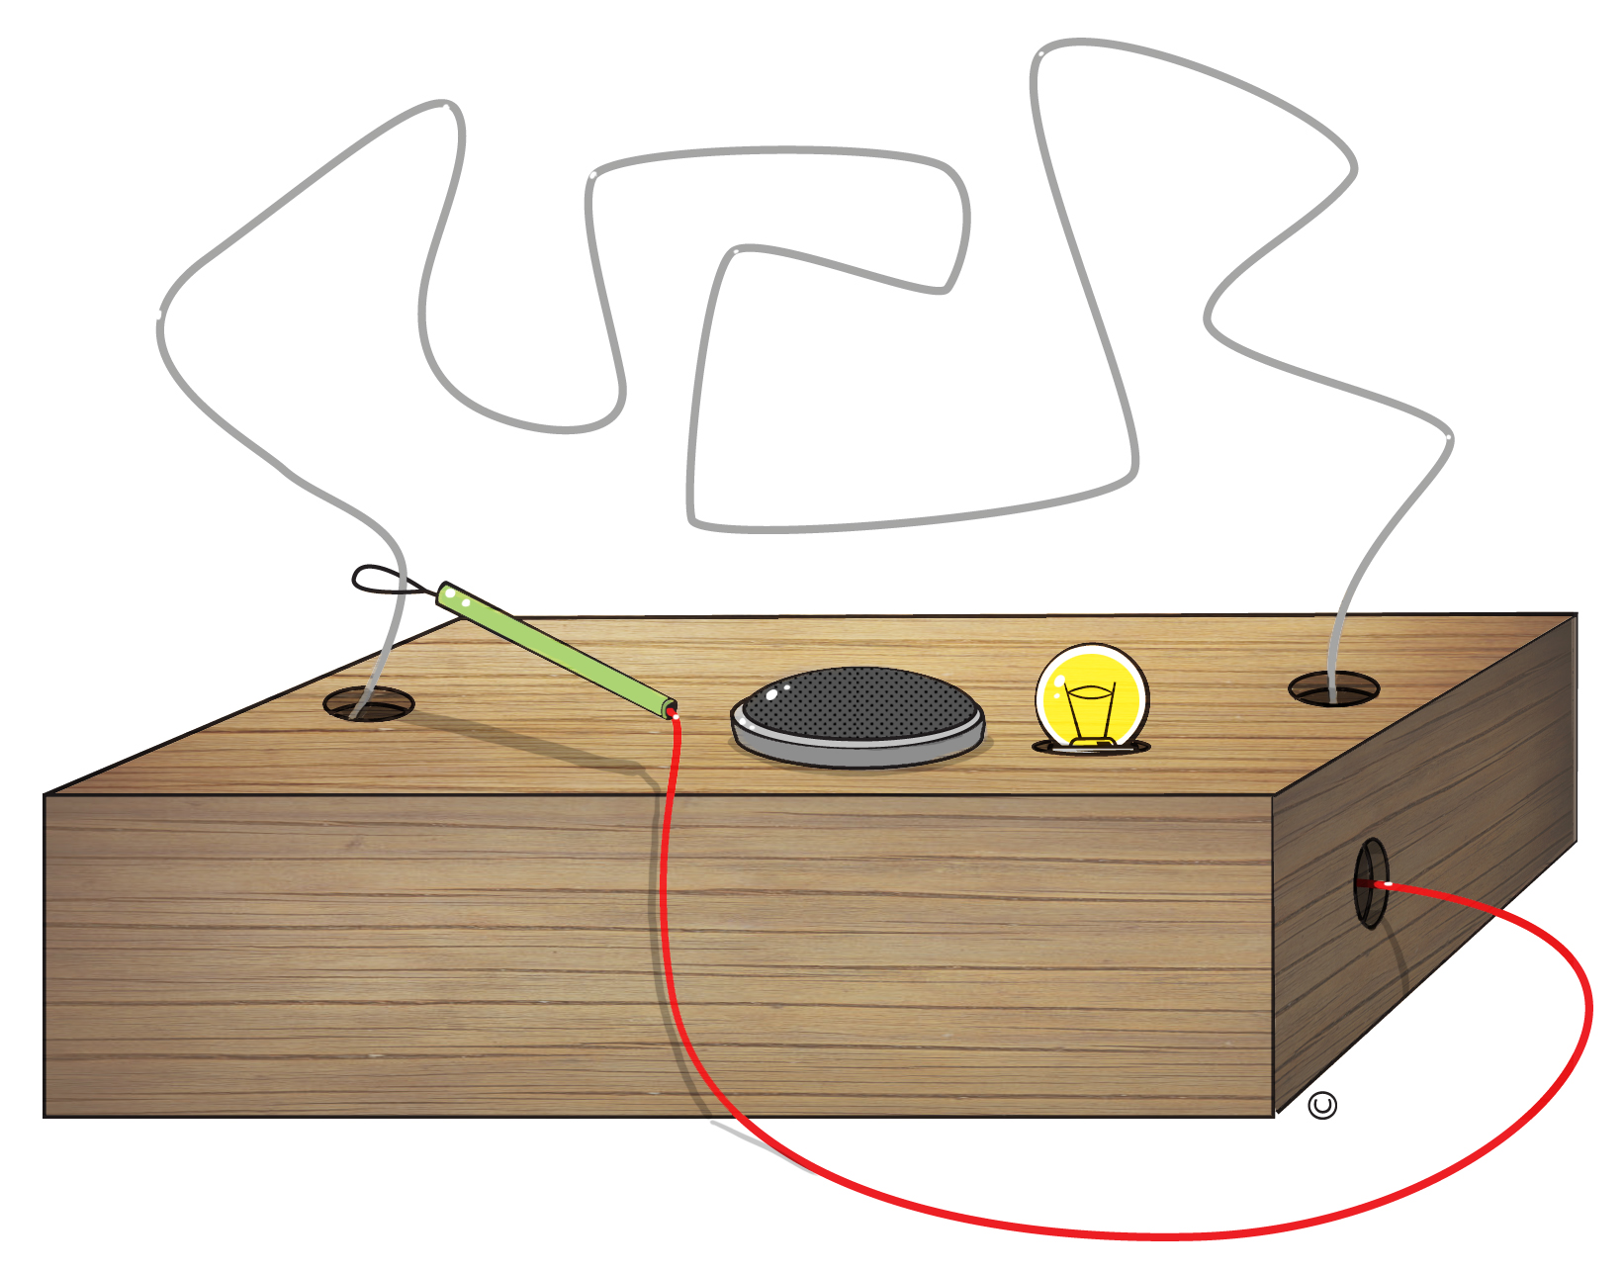
External features of the Steady Hand Game
This game requires the player to move a small metal loop from one end of the wire course to the other without touching the wire.
When the loop of wire touches the course, the small light and buzzer are supposed to turn on. If the buzzer and light turn on, the player has lost the game.
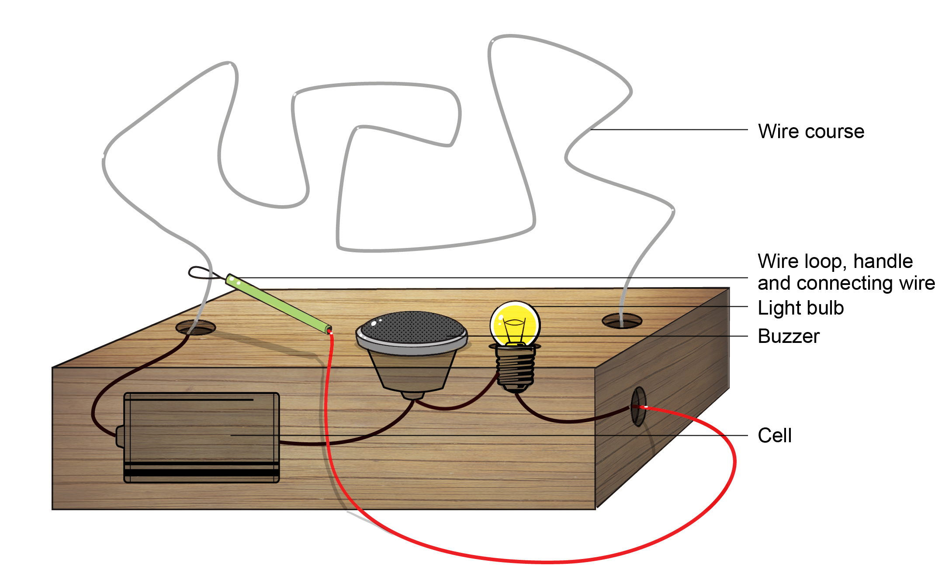
Internal features of the Steady Hand Game
Plan
The components of the Steady Hand Game have been removed from the game, so that you can test each one separately to identify why the game doesn’t work properly.
- You will build a circuit to test each of these components from the game:
  - Wire course
  - Wire loop, handle and connecting wire
  - Light bulb
  - Buzzer
- In the first box below, draw a labelled diagram of how you will set up your testing circuit.
- In the second box, draw a circuit diagram of the testing circuit you will build. Hint: use the following symbols in your circuit diagram.
 |  |  | 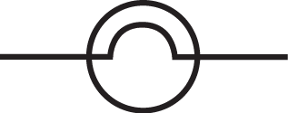
- Labelled diagram | - Circuit diagram
- Explain how you will use your testing circuit to identify which component is faulty.
Use additional pages if required.
Submit your diagrams and method for approval before building your circuit and conducting the tests.
This method is safe and practical.
It has been approved and any necessary changes have been made.
Signed by teacher: Date:
Conduct
- Build your testing circuit according to your approved diagrams.
- Follow your approved method for testing each component of the Steady Hand Game, and record your observations in the table below.
Component | Observations
Wire course
Wire loop, handle and connecting wire
Light bulb
Buzzer
- Analyse why the Steady Hand Game has been allowing everyone to win. Use your observations and your science knowledge.
- What changes can be made to the Steady hand game in order for it to work properly? Explain how these changes will allow the game to work properly.
Part B: Energy sources
The show is scheduled to travel to three locations around Queensland:
- An island
- A desert area
- A coal mining area
- The show owners need to make sure there is enough electricity to run the rides and games at each of their destinations. You need to use your science knowledge to choose an appropriate energy source that will support the show in each of the different locations. Choose a different energy source for each location and answer the questions in relation to each energy source.
- An island
- Energy source:
- Use a flow diagram to represent the sequence of energy transformations that need to occur for electricity generation using this energy source.

- Explain the energy transformations in the sequence.

- Identify advantages and disadvantages of using this source:
Advantages | Disadvantages
- Justify why this source is the best choice for the show owners. Remember to use your science knowledge and appropriate science terminology.

2. A desert area
- Energy source:
- Use a flow diagram to represent the sequence of energy transformations that need to occur for electricity generation using this energy source.

- Explain the energy transformations in the sequence.

- Identify advantages and disadvantages of using this source.
Advantages | Disadvantages
- Justify why this source is the best choice for the show owners. Remember to use your science knowledge and appropriate science terminology.

3. A coal-mining area
- Energy source:
- Use a flow diagram to represent the sequence of energy transformations that need to occur for electricity generation using this energy source.

- Explain the energy transformations in the sequence.
- Identify advantages and disadvantages of using this source.
Advantages | Disadvantages
- Justify why this source is the best choice for the show owners. Remember to use your science knowledge and appropriate science terminology.

4. Explain how having an understanding of the ways electricity can be generated would help the show owners select the most suitable energy source in each location.

Year 6 Science: Unit 2 — Energy and electricity: Exploring energy and electricity | Name:
Purpose of assessment: To analyse requirements for the transfer of electricity in a circuit and describe how energy can be transformed from one form to another to generate electricity. To explain how scientific knowledge is used to assess energy sources selected for a specific purpose.
Science Understanding |  |  | Science as a Human Endeavour |  |  | Science Inquiry Skills
Physical sciences |  |  | Use and influence of science |  |  | Communicating
Analyse requirements for the transfer of electricity and describe how energy can be transformed from one form to another when generating electricity. |  |  | Explain how scientific knowledge helps us to solve problems and inform decisions. |  |  | Construct multimodal texts to communicate ideas and findings.
 |  | Explains how changes to the circuit will enable the transfer of electricity. Explains the energy transformations occurring during electricity generation. |  |  | Justifies how science knowledge is used in the selection of energy sources in each location. |  |  | Constructs multimodal texts and uses accurate scientific language to comprehensively communicate ideas and findings. | A
 |  | Explains how a testing circuit can be used to accurately identify a faulty component. |  |  | Identifies advantages and disadvantages of some energy sources. |  |  | Communicates ideas and findings using relevant scientific language and representations. | B
 |  | Analyses requirements for the transfer of electricity and describes how energy can be transformed from one form to another when generating electricity. |  |  | Explains how scientific knowledge helps us to solve problems and inform decisions. |  |  | Constructs multimodal texts to communicate ideas and findings. | C
 |  | Identifies a fault in a circuit. |  |  | Identifies that scientific knowledge is used in decision making. |  |  | Uses everyday language. | D
 |  | Identifies an energy form. |  |  | States an energy source. |  |  | Uses fragmented language. | E

Feedback:

